BPM Calibration Timing
Ron Johnson, Steve Smith
Nov. 2, 2006
A calibration cycle consists of:
- Selecting which input gets driven by the calibration tone
- turning on the calibratot
- pulsing the calibration signal
- turning off the calibrator and restoring the inputs to operation mode
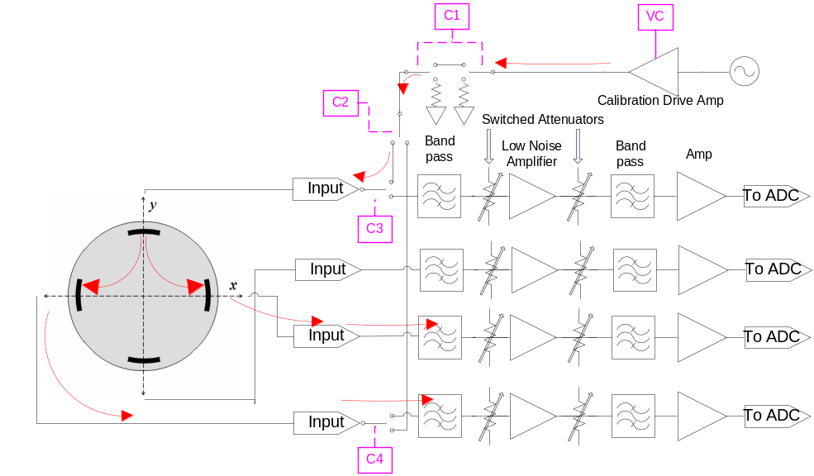

Figure 1. Block diagram showing signal paths for “Red” calibration

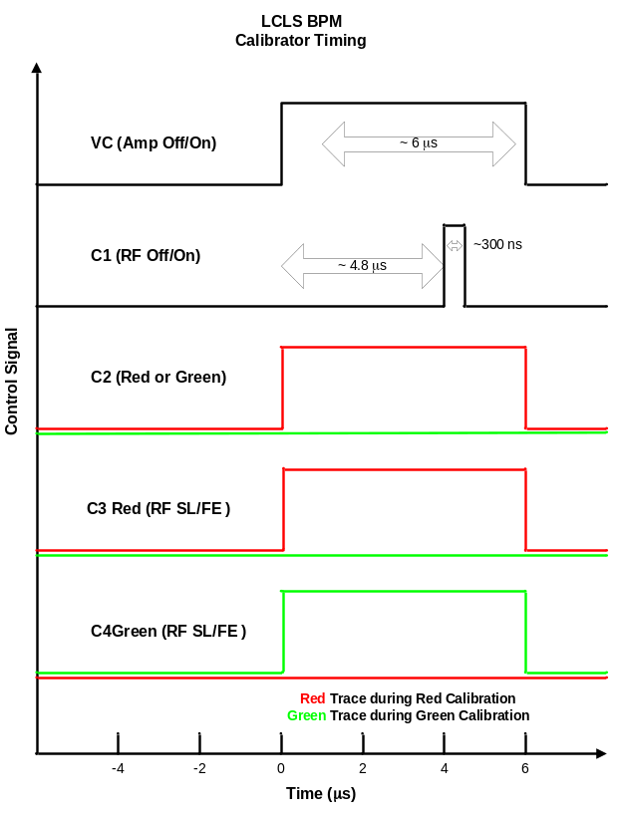
Figure 2. Timing diagram.

